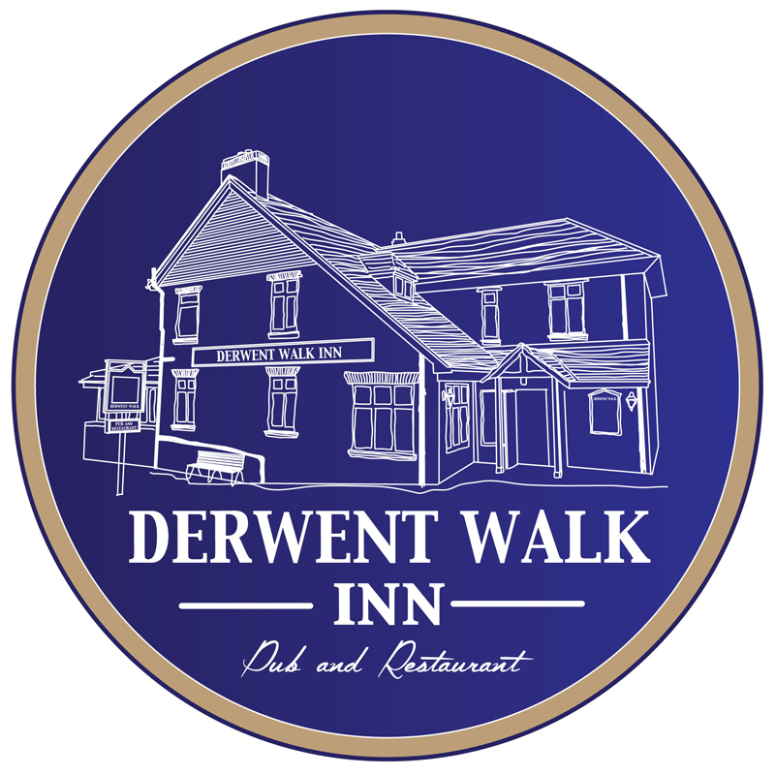
Christmas Fayre Menu 2019
Starters
- Lentil, Carrot & Slow Cooked Ham Soup
Served with crusty bloomer & butter. £4.50

- Roasted Mushroom, Cheddar & Brie Tart (v)
Nestled on a crisp salad with slow roasted tomatoes. Drizzled
With a sweet cranberry & balsamic vinaigrette. £5.95

- Prawn Cocktail
Succulent tiger prawns in a marie rose sauce. Nestled on a
Mixed leaf, cucumber & tomato salad. Served with wholemeal
Bread & butter fingers. £6.95

- Thai Spiced Nonja Chicken Goujons
Served with a crisp salad garnish & a sweet chilli or bbq dipping sauce. £5.95

- Chicken Tikka & Spring Onion Pakoras
Infused with Indian spices & fresh coriander. Accompanied with
A crisp salad garnish & a mint & mango riatha. £5.95

- Pan Roasted Asparagus Spears & Wilted Goats Cheese (v)
With garlic roasted tomatoes & basil pesto. £6.95

Main Courses

- Roast Breast of Northumberland Turkey
Served with bacon & chipolata sausage, Yorkshire Pudding & a sage & onion stuffing. Accompanied with new & roast potatoes, seasonal vegetables & rich roast gravy. £10.95

- Indian Spiced Lamb Burger
In a soft roll with bacon, onion bahjis & a mint & mango curry mayo. Served with homemade chips. £11.95

- Pan Roasted Breast of Chicken
Stuffed with haggis & a garlic herb butter, wrapped in bacon. Nestled on a quenelle of mash. Served with a whiskey cream sauce. £11.95

- Roast Sirloin of Beef
Served with new & roast potatoes & a Yorkshire Pudding. Accompanied with seasonal vegetables & rich roast gravy. £12.95

- Thai Green King Prawn Curry
With spring onions, peppers, carrots & mushrooms. Infused with fresh coriander, chilli, coconut milk & cream. Served with steamed rice & prawn crackers. £12.95

- Vegetarian Nut Roast Pie with Cranberries (v)
Served with new & roast potatoes, seasonal vegetables & a vegetarian gravy. £10.95

*A selection of desserts will be available to choose from on our dessert boards. Also tea, coffees, hot chocolate & liqueur coffees*

