TWO COURSE TRADITIONAL ROAST LUNCH

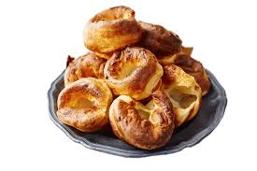Available Mon-Sat from 12pm until 8pm
Sunday 12pm-7pm

Starter: Homemade Lentil & Vegetable Soup. Served with fresh bread &
butter.

Main Courses: Roast Topside of Beef, Roast Gammon Ham, Roast Breast of Turkey, Roast Loin of Pork or Chicken Breast.

All served with potatoes, a selection of vegetables, Yorkshire pudding & rich roast gravy.

Full Portion: £14.95 / Half Portion: £12.50
Or
Main Course Only: £12.95 / Half Portion £10.95

We can also design buffets to suit your requirements for weddings, christenings, funerals & other celebrations.
Please ask to speak to Steve or email us at
derwentwalkinn@gmail.com

Our full menu is also available everyday….

